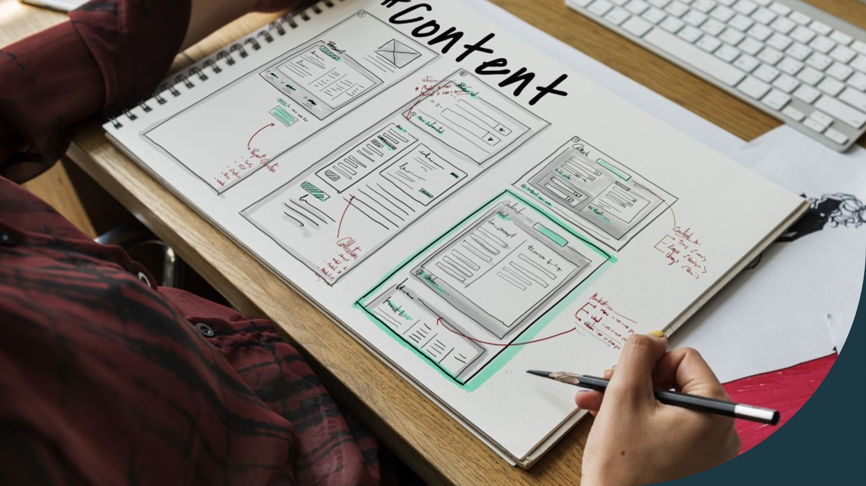
Business Plan

Contents
Introduction 2
Overview 2
Venture Creation ( Juice factory overview ) 3
Work process flow 4
Target market 6
Juice components 6
The skill needed for juice factory 7
The location and area of ​​the project 7
The requirements that the project needs 8
Marketing strategy 9
WBS for the project 13
Balance sheet 16
Income statement 18
Break-even analysis 20
Risk analysis 22
SWOT analysis 22
Payment methods through Application , Website, and stores 24
Gross strategy 25
Conclusion 25
References 26

Introduction
There is a primary goal for a feasibility study, it is a report that prefers to do the idea, and there are sub-goals, the most important of which we mention: -
- Knowing and identifying alternative opportunities available for investment.
- Creating effective methods and patterns for evaluating projects and developing them for the feasibility of the feasibility study, as the feasibility study should not be wasted because it is an economic study. Study particular concepts, and deepen them in all aspects of projects, from the technical, technical, financial, and economic factors.
- Adopting advanced techniques in marketing and focusing on marketing studies.
- Customize the types of technologies used in the projects. Knowing the possibility of providing expansion plans and programs for current industries, understanding the economic effects of the proposals, and knowing the mutual influences between them and the economy.
- Determine the idea's good and potential bad outcomes before investing a sum of money in it.
- Provide qualitative information to decision-makers.

Overview
The first step to establishing a juice factory project is to define goals, and these goals can be divided into primary and secondary. Goals and objectives are the project's starting point, such as determining annual profits and losses, what market we will target, what we are looking for from an expansion plan, and identifying stakeholders, production standards, raw materials, machinery, and staff. Supporting the components of this plan with individuals who have increased experience and efficiency will increase the success of the project
Identifying the human elements and choosing them carefully from the most important reasons for success through using strengths and weaknesses in analyzing each of them and identifying their needs and individual differences.
The project implementation and monitoring continue as long as the project operations are ongoing, using project management tools.

Venture Creation ( Juice factory overview )
The goal of setting up such projects is to produce juices using simple and affordable technologies for young people with the use of quality and safety standards for the product to come out with a product free of any pollutants and of high quality and low costs to achieve good profitability for young investors and at the same time develop the local market.
The beverage industry plays a significant role in promoting food self-sufficiency and import costs. On the other hand, population growth and improved living conditions have increased demand for them, thus increasing the need to invest in this sector and produce local food to meet the increasing demand for these products, including Juice, and the idea of the project is to establish a juice factory to produce natural juices in different flavors, and the project targets many sectors such as supermarkets, hotels, restaurants, and cafes.

Work process flow

Fruits

Preparing and processing fruits

Wash and sort the fruit

Add sugar

Add the sour

Filter the drink

Encapsulation

Sales

The manufacturing phase will be in several stages. First, farmers and owners of farms will be contracted with long-term contracts to purchase fruit from them. Also, some types of fruit will be imported from abroad which do not grow in the country. Through the new machines we have purchased, you will squeeze fruits with some preservatives, then they will be packed, and here comes the role of the sales department.
Small and medium food processing projects are considered one of the best solutions to maintain agricultural production. Food industries include many projects on which the national economy depends, and in light of the political leadership support for many small and medium projects. The Central Bank for Finance initiative places such projects within projects with an extensive marketing spread in the local markets, and the state supports the export of produced products through the Industrial Modernization Agency of the Ministry of Industry and Internal Trade. These projects are essential to link with the excellent and extremist lands of the country by benefiting from the products so as not to cause damage to them due to the long distance between the places of production and the distribution points.
The goal of establishing such projects
Produce juices using simple and affordable technologies for young people with the use of quality and safety standards for the product to come out with a product free of any pollutants and of high quality and low costs to achieve good profitability for young and at the same time develop the local market
The importance of the project
Benefiting from agricultural raw materials, whether they are fruits or vegetables in the new agrarian regions, in producing products that have a large marketing segment and a long shelf life.

Target market
Many young people, children, and the elderly tend to buy different types of juice from the shops instead of soda. Many studies have proven it harmful to the body and cause many diseases. The buyers' shift from buying them came due to awareness campaigns issued by several doctors. In addition, it contains high nutritional values that are beneficial to the body and do no harm.

Juice components

The project raw materials are available from fresh fruits and sugar preservatives throughout the year and these materials consist of
1- Fresh fruits such as: (Pears, oranges, plums, dates, apples, figs, guava, peaches, strawberries, grapes, apricots, bananas, pomegranates, mangoes.)
2- Dried products like :- (Tamarind, licorice)
3- Sugary substances such as: (Sugar is considered the basis of food)
4- Extras like: (citric acid)
5- Preservative substance :- A catalyst for the product not being damaged (sodium benzoate).
6- Packs: (Bottles) standard shapes

The skill needed for juice factory

- Monitor and evaluate the performance of others, individuals and organizations
- Correct control and operation
- Operation control
- Ask questions, debate and criticism
- Skill of workers
- Quality machines
- Finished product quality

The location and area of ​​the project

The project location must be in a commercial and residential area in which the buying and selling and high population. The factory location must be 160 square meters; 80 square meters are devoted to storing fruits. This area must be prevented the presence of dust and ensure good hygiene. The floor must be tiled with coarse wood and the wall tiled with ceramics. It`s preferred to be close to consumers to reduce transportation costs and facilitate marketing. A large sign must be placed on the factory outside to introduce the factory to people. Care must be taken to expand and develop the project continuously, and the place and the area are among the most critical factors that help the project succeed. Therefore, the selection must be accurate so that it is suitable for transportation and marketing operations.

The requirements that the project needs
- The project needs a fireplace.
- It will also need fruit cleaning tanks.
- Fruit exfoliation units.
- Squeeze units using pressure to be used in the squeezing orange.
- Bottle sterilization units, and fruit mincer.
- Sugar, lemon salt, sodium benzoate, and natural colors.
- Indian dates, hibiscus, and glass containers.
- Also to a group of screeners of different capacities.
- It is also a sorting and packing table.
- The project will need an amount of fruit.
- Nylon bags or carton or plastic packaging.
- The plant will need electricity sources.
- A source of clean water must be provided.
- There must be sources of ventilation for the fruit to be dried after being cleaned.

Marketing strategy
Marketing is considered one of the essential basics of the project, as the success of any project depends on how the marketing and the percentage of sales are and, therefore, marketing needs.
There are
group of steps to achieve success, especially in juice factory projects. We must follow the rules of selling products and buying raw materials. The products should be sold for less than the market price
Contacting wholesalers and retailers continuously. Participate in exhibitions to increase goodwill. Open at least one shop each year to sell products
Using social media marketing to increase the chance of expanding. We should use advertisements on YouTube, magazines, Facebook, Instagram, Twitter, and TVs. distribute goods to other cities to increase the goodwill and achieve high selling growth.
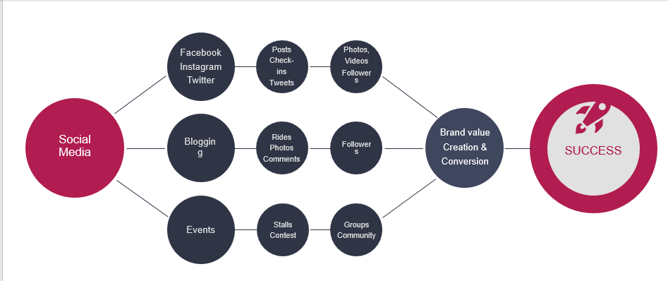
(Graph-1)

There are many steps for marketing strategy
- Social Media
Social media has a very big role in the success of any project. You can use Facebook, Instagram and Twitter, and also publish some paid advertisements to reach the largest number of people.
- Videos
One of the most popular methods currently in marketing is to create videos with many ideas. Attracting attention to the quality of the product, as we see videos of energy drinks, Red Bull.
- LinkedIn
LinkedIn can be used to market the company's reputation and introduce people to its value and size, and LinkedIn can also be used to search for competent employees, workers, and leaders

- Mobile application
Once finishing restructuring your marketing budget and providing the necessary resources for your applications, you need to find a plan to use that budget. Advertising and promotion of your applications should be creative and make consumers interact with our company , and it should also be continuous. Without planning your budget accordingly, you may run out of resources before finishing work. Your goal should be to keep your app visible in major markets throughout the year. For example, you could pay more during vacation times to get consumers to notice your apps
If our budget can afford to partner with a phone marketing technology provider, we may want to discuss this option with members of your team or any of the external agencies running mobile app marketing campaigns. This may devour part of your budget, but this tactic will provide our application with better success and an opportunity to achieve a higher ranking in the app stores.
Consumers today are looking for the simplest experiences offered by brands, in fact, 86% of them are more buyable when not overwhelmed with confusing information. Remember this when writing our app description on the app store. Market how the app can be simplified to the lives of users, and not every small task the app can do.

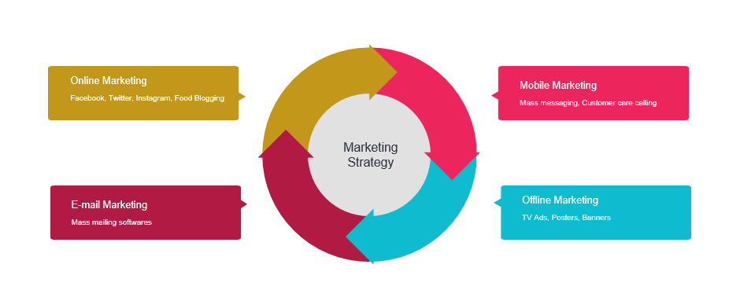
(Graph-2)

We should focus directly on the Key Performance Indicators for App Marketing.
Applications are a powerful marketing tool and therefore require allocating more marketing-oriented resources. Studies show that 80% of consumers want to receive local alerts on their mobile phones.
Once finishing restructuring marketing and providing the necessary resources for your applications, you need to find a plan to use that budget. Advertising and promotion of your applications should be creative and make consumers interact with our company, and it should also be continuous. Without planning your budget, you may run out of resources before finishing work. Your goal should be to keep your app visible in major markets throughout the year. For example, you could pay more during a vacation to get consumers to notice your apps. (Barone, 2020)

WBS for the project

WBS | Task name | Duration | Start | Finish | Resource Names |  |  | Cost
1 | Juice factory | 371 days? | W 07/01/20 | W 12/01/21 |  |  |  | £1,050,000.00
1.1 | buying land | 50 days | W 07/01/20 | T 09/08/20 | land |  |  | £500,000.00
1.2 | Constructions | 200 days | T 09/08/20 | M 06/14/21 | construction |  |  | £250,000.00
1.3 | Finishes and decors | 75 days | M 06/21/21 | F 10/01/21 | Decoration |  |  | £25,000.00
1.4 | Buying machines | 30 days | T 06/15/21 | M 07/26/21 | machine cost |  |  | £150,000.00
1.5 | Renting two shops | 30 days | T 06/15/21 | M 07/26/21 | Annual renting |  |  | £60,000.00
1.6 | website | 30 days | M 10/04/21 | F 11/12/21 | Creating website |  |  | £2,000.00
1.7 | Mobile application | 30 days | M 10/04/21 | F 11/12/21 | Mob. Application |  |  | £1,000.00
1.8 | buying raw material | 30 days | F 01/01/21 | T 02/11/21 | raw material |  |  | £50,000.00
1.9 | Recurring | 30 days | T 07/27/21 | M 09/06/21 | recurring |  |  | £2,000.00
1.10 | Marketing | 90 days | T 07/27/21 | M 11/29/21 | marketing |  |  | £10,000.00
1.11 | starting | 1 day | W 12/01/21 | W 12/01/21
(Table-1)- WBS

- Using Microsoft Project, we created WBS for the juice factory project. The factory's expected construction duration from start to finish is about a year (371 days). The opening will be to search for a plot of land in an industrial area to be among the most robust factory, create a competitive environment, and seek our rapid reputation. That mission will take about 50 days to search, buy, pay, and transparent government official papers to ensure ownership of the land and its insurance, and the expected cost is half a million pounds.

- The next task is searching for and contracting with a contracting company to build the factory. The expected duration of construction is 200 days, and the expected cost is also 250,000 pounds.

- The third task is to finish the decorations and beautify the factory. The duration of that mission is 75 days and an estimated cost of 25,000 pounds.

- The fourth task is to buy the machines and equipment needed to squeeze the juice and clean it for one month, and the machinery cost may reach 150,000 pounds.

- The fifth task is to rent two shops, one in the same town and the other in another city, and the rent for the two stores in the year may reach 60 thousand pounds at an average of two thousand pounds for each store. Still, there is a period that may take a month, and we will take it to search for convenience stores in vital places between many From shops and exhibitions.

- The sixth and seventh missions can be summarized in one task, which is research and contracting with a professional software company and contracting, no matter how to create a unique and unique website through which all the products of the factory can be displayed, and there can also be a live chat with customer service and multiple payment methods. The mobile application is straightforward and can communicate with all the factory branches and stores to deliver orders to cafes, restaurants, retail stores, and wholesale stores. The cost of the mobile application and the website may reach 3000 pounds, and the duration of each is about a month.

- The eighth mission is to buy raw materials and fruits, which takes about a month and may cost up to 50 thousand pounds.

- The ninth task is to search for workers, accountants, employees, and distributors, you can say (search for the complete supply chain episode), and the search takes about a month. The estimated cost may reach two thousand pounds, and this cost is in some advertisements and communication with some of the outsourcing companies.

- The pre-final mission is marketing (marketing for the factory, branches, website, mobile application, and all the company's products) and, as we mentioned later in the marketing strategy.

- The last stage: Opening the production line, providing the branches with products, starting with a beautiful celebration, and inviting all stakeholders to attend the opening.

Balance sheet

Assets
Current assets:
Cash | 250,000 | 375,000 | 562,500
Accounts Receivable | - | 75,000 | 112,500
Prepaid expenses | 60,000 | 90,000 | 135,000
Inventory | 50,000 | 75,000 | 112,500
Total current assets | 360,000 | 615,000 | 922,500
Property & Equipment | 907,000 | 1,360,500 | 2,040,750
Goodwill | - | 150,000 | 250
Total Assets | 1,267,000 | 2,125,500 | 2,963,500
Liabilities
Current liabilities:
Accounts Payable | - | 60,000 | 120,000
Accrued expenses | - | 1,541 | 70,000
Unearned revenue | - | 1,560 | 1,853
Total current liabilities | - | 63,101 | 191,853
Long-term debt | - | 50,000 | 30,000
Other long-term liabilities | - | 5,872 | 5,565
Total Liabilities | - | 118,973 | 227,418
Shareholder's Equity
Equity Capital | 1,267,000 | 170,000 | 210,000
Total Liabilities & Shareholder's Equity | 1,267,000 | 1,955,500 | 2,736,082
(Table-2)- Balance Sheet

The balance sheet is at the beginning of the first year of the assets and consists of cash. The company must possess about 25,000 pounds and prepaid expenses, which is worth 60 thousand pounds, which is the value for the rent of the two stores, either for the value of the stock, which is 50 thousand pounds, which is the value to Tamm Put it at the beginning of the project. The value of the Property & Equipment is worth £ 907,000. Goodwill will initially be zero. However, the multiplayer for each year is 1.5 times the previous year's value for Liabilities. Since we bear the project's entire cost, Accounts Payable, Accrued expenses, Unearned revenue, Long-term debt, and other long-term liabilities are zero in the first year.

Income statement

Revenue |  | first year | Second year | Third year
 | Gross sales | 560,000 | 710,000 | 830,000
 | (Less sales returns and allowances) | (10,000) | (15,000) | (22,500)
 | Net Sales | 550,000 | 695,000 | 807,500
Cost of Goods Sold
 | Beginning inventory | 50,000 | 75,000 | 112,500
 | Goods purchased | 250,000 | 375,000 | 562,500
 | Goods manufactured: Raw materials | 10,000 | 15,000 | 22,500
 | Goods manufactured: Direct Labor | 40,000 | 60,000 | 90,000
 | Total Goods Available | 350,000 | 400,000 | 500,000
 | (Less ending inventory) | 5,000 | 7,500 | 11,250
 | Cost of Goods Sold | 355,000 | 407,500 | 511,250
 | Gross Profit (Loss) | 195,000 | 287,500 | 296,250
Expenses
 | Advertising | 2,000 | 3,000 | 4,500
 | Bad debt | - | - | -
 | Commissions | 2,000 | 3,000 | 4,500
 | Depreciation | 16,616 | 24,924 | 37,386
 | Employee benefits | 15,000 | 22,500 | 33,750
 | Furniture and equipment | 25,000 | 37,500 | 56,250
 | Insurance | 20,000 | 30,000 | 45,000
 | Maintenance and repairs | 2,000 | 3,000 | 4,500
 | Office supplies | 3,000 | 4,500 | 6,750
 | Payroll taxes | 30,000 | 45,000 | 67,500
 | Rent | 60,000 | 90,000 | 135,000
 | Research and development | 3,000 | 4,500 | 6,750
 | Salaries and wages | 40,000 | 60,000 | 90,000
 | Software | 500 | 750 | 1,125
 | Travel | - | - | -
 | Utilities | 10,000 | 15,000 | 22,500
 | Web hosting and domains | 50 | 75 | 113
 | Other | 16,192 | 24,288 | 36,432
 | Total Operating Expenses | 245,358 | 368,037 | 552,056
Operating Income (Loss) |  | (50,358) | (80,537) | (255,806)
 | Non-operating revenues, expenses, gains, losses
 | (Less interest expense)
 | Income Before Taxes | (50,358) | (80,537) | (255,806)
 | (Less income tax expense) | (1,069)
Income From Continuing Operations |  | (51,427) | (80,537) | (255,806)
(Table-3)- Income Statement

Break-even analysis

Year | Gross margin | Gross margin | Break even analysis | Units | Increasing per units | Increasing per percent
First Year | $$\frac{560000-355000}{560000}$$ | 0.366 | = 245,358 * 0.366 | 89801
Second Year | $$\frac{710000-407500}{710000}$$ | 0.426 | =368,037 * 0.426 | 156784 | 66983 | 0.427231
Third year | $$\frac{830000-511250}{830000}$$ | 0.384 | = 552,056 * 0.384 | 219718 | 62934 | 0.286431
(Table-5)- BEA

We notice through Break even analysis that the increase in products continues every year. In the second year, there was an increase in the number of units by 0.427231, equivalent to 66,983 units. In the third year there was an increase of 0.286431, equivalent to 62,934 units

(Graph-3)

Parity point analysis can help us analyze total revenue with total costs (variable + fixed).
We will arrive at a certain point, knowing that we are equating revenue with expenses and not earning anything. When more and continue to produce, more production will be achieved, and this means that the company will make a profit, and if the volume of production falls below this point, this means that the company will accomplish a loss, and to reach this point, the costs must be analyzed and classified according to their relationship to the volume of production To fixed costs and variable costs.
through Break-even analysis we can gain several benefits :-
- Learn the impact of fixed and variable costs on profits, in order to reduce them.
- Identify potential profits at any point of production .
- Which volume of sales is required to achieve profits
- Determining the minimum and the maximum we can.

Risk analysis
Biological Risks: These are the risks caused by bacteria, viruses, and fungi.
Chemical risks: Includes the use of untrained food additives such as coloring salts and acids, pesticides, antibiotics.
Natural risks: solid materials such as small metal parts, stones, and vitrified stones that may harm the gastrointestinal tract.

SWOT analysis

- Strengths:
The strengths of any company are its reputation and continued production without any problems or suspicions and the pursuit of purchasing new production machines to increase production capacity, quality of the final product, and continuous and increasing parallel lines. Various products for juices, engineers, technicians, and high-quality workers can elevate the company's name and reputation. The company does not produce one type of juice but instead has more than 25 types of juices in addition to cocktails.

- Weakness
The internal weaknesses points are represented in the size of the workforce, the management vision, and the strategic plan. The quality of the machines we work with, poor quality workers, or high employee turnover. We can measure weaknesses from another area, which is the wrong administrative and executive area, and the lack of foresight in expansion.

- Opportunities
The company's opportunities are in the large multi-market in England and Europe, and it can also export to Asia and Africa. The company's internet presence provided a perfect opportunity to announce its size and popularity. There is a perfect opportunity to expand and open more than one store in more than one country.

- Weaknesses
The juice factory's external weakness is the technology volume that is constantly increasing and multiplying. for example, if factories with high liquidity bought many machines, our market position would be fragile.

Payment methods through Application , Website, and stores
The payment policy adopted by our juice factory . We will leave everything to customers, they will pay cash through more than one method, and those payments will be developed through the software company that will undertake the creation of the mobile application and our website..
1- Bank transfer
2- Cash
3- Credit cards
4- Payment via check
5- Payment via mobile money transfer
6- Payment via bank draft

Gross strategy
It was mentioned later that we would own a juice factory in addition to two stores, one in the same city and the other in another. Let there be an expansion strategy by opening at least one store every year in a different city with many offers and discounts every time and on occasion.

Conclusion

The idea of setting up a juice factory of all kinds and having more than 25 types of juices other than cocktails is worthy of attention. The future forecasts that we made in the balance sheet and the income statement indicate that there is an increased profit every year other than the expansion plan to open a store every year in a different city.

References
A. F. M. Rubayat-Ul Jannat, 2010. slideshare. [Online]
Available at: https://www.slideshare.net/rubayatppt/business-plan-smoothy-juice
[Accessed 13 July 2010].
Adams, R., 2017. entrepreneur. [Online]
Available at: https://www.entrepreneur.com/article/299335
[Accessed 12 September 2017].
AlveeMahtab, n.d. slideshare. [Online]
Available at: https://www.slideshare.net/AlveeMahtab/report-on-fruit-juice
Ashraf, R., 2015. slideshare. [Online]
Available at: https://www.slideshare.net/RakeebAshraf/marketing-plan-for-new-juice-product
[Accessed 5 May 2015].
Barone, A., 2020. investopedia. [Online]
Available at: https://www.investopedia.com/terms/m/marketing-strategy.asp
[Accessed 29 April 2020].
Campbell, C., 2018. shopify. [Online]
Available at: https://www.shopify.com/blog/break-even-analysis
[Accessed 2 April 2018].
careertrend, n.d. careertrend. [Online]
Available at: https://careertrend.com/start-juice-factory-16967.html
Caswell, H., 2009. onlinelibrary. [Online]
Available at: https://onlinelibrary.wiley.com/doi/full/10.1111/j.1467-3010.2009.01760.x
[Accessed 4 Augest 2009].
cleartax, 2020. cleartax. [Online]
Available at: https://cleartax.in/s/break-even-analysis
[Accessed 9 march 2020].
Duermyer, R., 2019. thebalancesmb. [Online]
Available at: https://www.thebalancesmb.com/marketing-strategy-for-home-business-success-1794314
[Accessed 11 Feburary 2019].
engineering, n.d. engineering. [Online]
Available at: https://www.engineering-bp.com/en/news-index/articles-and-publications/the-process-of-production-of-juices-and-concentrates-in-a-nutshell/34
Fey, J. J. H., 2000. Design of a fruit juice blending and packaging plant. Eindhoven: Technische UniversiteitEindhoven.
Group, A. -. B. P., 2013. slideshare. [Online]
Available at: https://www.slideshare.net/shaikhyusuf619/marketing-for-new-juice-product
[Accessed 15 December 2013].
Jones, J., n.d. smallbusiness. [Online]
Available at: https://smallbusiness.chron.com/start-juice-factory-17712.html
Ryan, R., 2014. sciencedirect. [Online]
Available at: https://www.sciencedirect.com/topics/biochemistry-genetics-and-molecular-biology/fruit-juice
[Accessed 2014].
simplilearn, 2020. simplilearn. [Online]
Available at: https://www.simplilearn.com/feasibility-study-article
[Accessed 23 March 2020].
Taylor, J., 2017. essaytyping. [Online]
Available at: https://www.essaytyping.com/diwai-frozen-juice-company-swot-analysis/
[Accessed 22 Augest 2017].

