Contents
Overview 3
Most important information 4
Incentives in New-Mexico Clovis 4
TAX 5
Overview Grants in New Mexico 6
PESTLE analysis 8
Political factors 8
Economic factors 9
Social factors 11
Technological factors 11
Legal factors 11
Environmental factors 12
Safety requirements 12
Ways to obtain grants from the US government in the state of New Mexico 13
Project lift cycle 15
SWOT analysis 17
Strengths 17
Weaknesses 18
Opportunities 19
Threats 19
The Available grants in New Mexico 19
The main expenses 21
Competitive advantage 21
Market segment 22
Market trends 24
Target market 25
Marketing plan 27
Recommendation 32
References 32

research design, and engineering of nuclear reactors, molten salt fission, and fusion concepts

Overview
(Molten salt reactor) MSR development worldwide is still at a conceptual design stage, with most investigations around these concepts based today on numerical modeling. The design and engineering of nuclear reactors, fission of molten salt, and fusion concepts is a vital activity that can generate substantial profits for us significantly since New Mexico surpasses many states in nuclear reactor engineering and energy.
In the United States, Congress has passed a nuclear innovation bill that encourages public-private partnerships to test and demonstrate concepts for advanced reactors and enhance public research laboratories' simulation and experimental capabilities. In February 2019, the US Department of Energy announced plans to build the Versatile Test Reactor or VTR. This new research reactor will help speed up the testing of advanced nuclear fuel and materials required to develop fourth-generation reactor systems. (energy, n.d.)
Progress is progressing in adopting the design of SMRs by nuclear safety authorities. The method of the Unscaled SMR is in the final stage of design certification by the NRC in the United States, and the process is expected to be completed in 2020. Plans to construct the first units of a new plant in Idaho have progressed with the selection of manufacturers and further support confirmed by the US Department of Energy. (Levitan, 2020)
The U.S. government has one significant cost-sharing agreement with an SMR developer for design and licensing costs. It has handed out lots of awards of small amounts of money ($millions) for slices of technology development but hasn’t committed to creating an industry ($billions).
When comparing the ES 2050 targets to the revised assumptions, by 2035, we will have much more energy than the ES 2050 assumes because nuclear power plants will generate electricity for a more extended period. Thus, nuclear energy is a “major bridge technology ”under ES 2050. However, the lack of production from hydroelectric power, geothermal energy, and winds will lead to a deficit in production in the year 2050. Therefore, our company must accelerate production to reserve a percentage of the market according to the next global plan. (Yurman, 2019)

Most important information
- This information was obtained according to Clovis County, as it belongs to the state of New Mexico, and what can be provided by the state in terms of some incentives and vital information that can benefit business continuity.
- NM's operating budget for the 2020 fiscal year is $7.068 billion, a 12 percent increase from FY19.
- New Mexico ranks 2nd in the US in known uranium reserves, with rich uranium deposits in the Grants Mineral Belt traversing McKinley & Cibola Counties.
- According to Anniversary Report 2018, New Mexico has the third-largest sovereign wealth fund globally; only Alaska and Texas have more significant funds. Over the past eight years, the funds have contributed $6.2 billion to the state, while the value of the funds has increased by $9.7 billion, growing to $23.6 billion.

Incentives in New-Mexico Clovis

- New Mexico provides several economic incentives to businesses operating in the state, including various types of tax credits and tax exemptions. Most of the incentives are based on job creation.
- New Mexico law allows governments to provide land, buildings, and infrastructure to businesses to promote job creation. Several municipalities have imposed an Economic Development Gross Receipts Tax (a form of Municipal Infrastructure GRT) used to pay for these infrastructure improvements and to market their areas.
- The state provides financial incentives for film production. The New Mexico Film Office estimated at the end of 2007 that the incentive program had brought more than 85 film projects to the state since 2003 and had added $1.2 billion to the economy. (elibrary, n.d.)

TAX
- Since 2008, personal income tax rates for New Mexico have ranged from 1.7% to 4.9%, within four income brackets. As of 2007, active-duty military salaries are exempt from state income tax. New Mexico is one of the largest tax havens in the US, offering numerous economic incentives and tax breaks on personal and corporate income. It does not have an inheritance tax, estate tax, or sales tax.
- New Mexico imposes a Gross Receipts Tax (GRT) on many transactions, including some governmental receipts. This resembles a sales tax, but unlike the sales taxes in many states, it applies to services and tangible goods. Usually, the provider or seller passes the tax on to the purchaser. However, legal incidence and burden apply to the business as an excise tax. The state imposes GRT, and there may be an additional locality component to produce a total tax rate.
- Property tax is imposed on real property by the state, counties, and school districts. In general, personal-use personal property is not subject to property taxation. On the other hand, property tax is levied on most business-use personal property. The taxable value of the property is 1/3 of the assessed value. A tax rate of about 30 mills is applied to the taxable value, resulting in an effective tax rate of about 1%. In the 2005 tax year, the average millage was approximately 26.47 for residential and 29.80 for non-residential properties. Assessed values of residences cannot be increased by more than 3% per year unless the home is remodeled or sold. Property tax deductions are available for military veterans and heads of households.
- The comprehensive tax system in the United States is progressive.
- High-income earners pay more than total taxes, but they also produce a high tax rate.
- The highest gross sales tax rate in the United States is 13.725 percent.
- All taxable income is at 34% to 35% as it exceeds the taxable income of $ 335,000.
- The average American pays 19.8% of their income in federal taxes.

Overview Grants in New Mexico
The Land Grant Standing Fund is created by royalties raised by the state land office. The SIC receives monthly contributions (royalties) to the LGPF from the State Land Office. They invest these contributions while simultaneously distributing monthly payments to the beneficiaries. We got this information because it could be helpful when starting to build a factory with grants from the state. (sic, n.d.)

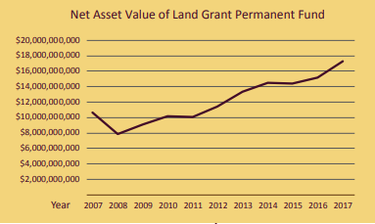
Figure-1 Land value grants (Moise، 2018)

V.I.Note

This information can be used to obtain a plot of land to build the factory when promoting a business

PESTLE analysis
PESTLE analysis has been approved by Clovis County and some important information that may be important for the state of New Mexico and what can be useful to us in the investment process

Figure-2 (PESTLE analysis)

Political factors
There is a Democratic majority in both New Mexico state legislature houses. The policy is very high inefficiency. There is excellent support from the government for new and minor projects. The Business Acceleration Program for Startups is uniquely suited to scale startups in their region and around the world. The program targets the creative economy and is based on the concepts of design thinking and the lean startup approach. Political factors that can affect your business include elections, government formation, and their impact on issues such as taxes and trade. America can encourage startups. So we can benefit from the government's incentives and facilitate some things. The main problem we may encounter is obtaining patents when creating a new design to avoid lawsuits against us. (biz, n.d.)

Economic factors
Clovis's three major sectors that drive its economy are agriculture, railways, and music.
The largest industries in Clovis, New Mexico, are retail, health care, social assistance, and public administration. Mining, quarrying, oil and gas extraction, utilities, transportation, and storage are the highest-paying industries. Therefore, entering a new type of business will manage a lot of profit for employers and benefit the state and its governments
year | inflation rate
2019 | U.S. inflation rate for 2019 was 1.81%, a 0.63% decline from 2018.
2018 | U.S. inflation rate for 2018 was 2.44%, a 0.31% increase from 2017.
2017 | U.S. inflation rate for 2017 was 2.13%, a 0.87% increase from 2016.
2016 | U.S. inflation rate for 2016 was 1.26%, a 1.14% increase from 2015.
Figure-3 (inflation rate in USA) (macrotrends, n.d.)

With a GDP of more than $ 16.760 trillion, the United States is the largest economy in the world. The economic system is developed and combines its strength from services and manufacturing industries.

year | inflation rate
2019 | Mexico inflation rate for 2019 was 3.64%, a 1.26% decline from 2018.
2018 | Mexico inflation rate for 2018 was 4.90%, a 1.14% decline from 2017.
2017 | Mexico inflation rate for 2017 was 6.04%, a 3.22% increase from 2016.
2016 | Mexico inflation rate for 2016 was 2.82%, a 0.1% increase from 2015.

Figure-4 (New-Mexico inflation rate ) (macrotrends, n.d.)
Inflation rates in America are meager. When looking at the inflation rates in New Mexico separately, we will find that they are also common. There is a tremendous economic diversity in America, especially in New Mexico, so it is a suitable environment for investment, with the state's support for emerging businesses.

Social factors
Environmental development in America, especially the state of New Mexico, so they can use our company products. Low salaries and some raw materials will facilitate many manufacturing and research operations. The United States faces an aging population that can lead to severe labor shortages and higher tax rates. But the increase in racial intolerance is a serious concern. Additionally, increasing illegal immigration is another concern, as there are currently more than 11.7 million people living illegally in the United States..

Technological factors
The United States is home to a third of the scientists and engineers in the world. We can obtain the maximum amount of technology and develop research and development processes through that. A third of global spending is on research and development.
Government research and development focuses on defense (58.3% of the R&D budget), and through that, we can get a lot of grants and privileges from the government and spend it on R&D.
A significant development in emerging technologies.

Legal factors
The executive branch of government is fragmented as outlined in the state constitution.
The judiciary is composed of the New Mexico Supreme Court and lower courts. There is also a local government, consisting of counties, municipalities, and special districts.

Environmental factors
In this context, the nuclear industry has been stimulated to design a new generation of power plants that exhibit much higher levels of safety against the possibility of radiation to reduce the risk and achieve safety and security standards.
The solution is perhaps the most critical technical issue of public opinion on the issue of the effects of low radiation levels on human health. Because it is radiation that the public is associated with in all areas of nuclear technology, it is natural that there is an unfounded fear of radiation. So there are some irregularities due to some atomic radiation

Safety requirements
The disposal of nuclear radioactive waste appears to be the most critical barrier to the future of atomic energy. While it is true that such materials remain radioactive for an extended period, if it is correct, they are recycled to maximize their energy content.
The primary responsibility for nuclear safety must lie with the responsible person or organization responsible for these activities. However, radiation risks may transcend national borders, and international cooperation encourages and enhances security at the global level by exchanging experiences and enhancing capabilities to control risks, prevent accidents, respond to emergencies, and mitigate any dire consequences.
The Agency is obligated under its statutes to promote international cooperation. Its laws authorize it to set or adopt safety standards to protect health and minimize risks to life and property. The Agency develops these standards based on an open and transparent process to collect, integrate, and share knowledge and experience gained from using technologies and the application of safety standards. The Safety Standards consist of three groups of publications: Safety Essentials, Safety Requirements, and Safety Guides (world-nuclear, n.d.)

Ways to obtain grants from the US government in the state of New Mexico
Under Executive Order 12372, some states require federal grant applicants to submit a copy of their application for state government review and comment. State offices listed here coordinate federal financial assistance and may direct national development. To help locate grants at the state level, websites of other state and local government agencies can be found.
Government grants are not available for small startups to start a business, pay off debt, or cover operating expenses. Unless your business is a nonprofit or launching a project related to areas such as technology, medical research, or education, grants can be challenging to find. 4 However, there are grants for small startups available for specific types of businesses and their owners, including:

- Innovators
- Green business
- Rural companies
- Women, veterans, or minority-owned businesses
- Non-profit organizations (buck.house, n.d.)

- SBA Economic Injury Disaster Loan (EIDL): Loans for businesses experiencing significant economic damage due to COVID-19 for a public health emergency. Firms qualify for a 3.75 percent interest (2.75 percent for nonprofits) and a 30-year loan of up to $ 2 million to pay operating expenses such as payroll, mortgages, accounts payable, and other bills. Payments may be deferred for up to one year. Small Business Development Centers in New Mexico have offered to help companies with paperwork. (sba, n.d.)

- New Mexico Recovery Fund: The New Mexico State Board of Investment created a $ 100 million emergency business loan program administered by Sun Mountain Capital for companies with 40 or more employees. New Mexico companies that were creditworthy before the pandemic may apply for loans, starting at $ 500,000, with interest rates ranging from 3% to 10%. The NM Redemption Fund targets companies: with significant negative impacts related to COVID-19; Demonstrates intent to retain as many employees as possible for the duration of the loan; will commit to spending at least 80% of loan proceeds in New Mexico (preferably spending 100% of loan proceeds in New Mexico). The information and eligibility questionnaire can be found at Sun Mountain Capital. (newmexico, n.d.)

Project lift cycle

WBS | Task Name | Duration | Start | Finish | Cost
1 | nuclear project | 119 days | Wed 2/3/21 | Mon 7/19/21
1.1 | Research the market | 30 days | Mon 3/1/21 | Fri 4/9/21
1.2 | grants steps | 90 days | Wed 2/3/21 | Tue 6/8/21
1.3 | Documents and papers | 30 days | Thu 2/11/21 | Wed 3/24/21 | 250$
1.4 | preparing tools and equipment’s | 45 days | Thu 3/25/21 | Wed 5/26/21 | 20,000$
1.5 | staff | 30 days | Mon 5/10/21 | Fri 6/18/21
1.6 | rent the office | 15 days | Sat 6/19/21 | Thu 7/8/21 | 10,000$
1.7 | starting the process | 7 days | Sat 7/10/21 | Mon 7/19/21
1.8 | marketing | 60 days | Thu 4/1/21 | Wed 6/23/21 | 400$
2 | upgrading step | 30 days | Thu 7/1/21 | Wed 8/11/21
2.1 | starting factory process | 20 days | Fri 7/1/22 | Thu 7/28/22 | 2m
2.2 | Factory settlement and finance | 300 days | Fri 10/1/21 | Thu 11/24/22
2.3 | upgrading the business | 50 days | Thu 12/1/22 | Wed 2/8/23
2.4 | The next step business | 10 days | Fri 2/10/23 | Thu 2/23/23
Figure-5( project life cycle )

V.I.Note

We can shift or move the time as we like based on the appropriate time to start the project, but the time gap between each stage and the other must be adhered to.

- In the first stage, we will search for competitors, problems that may face us, funding sources, grants, and government concessions.
- Moving to legalize official business papers whose value will not exceed $ 500, other than protection fees, if any
- Searching for a work team that will help us in work, which will consist of (accountant/lawyer / technical/administrative / according to the need of work)
- The annual estimate for office rent is ten thousand dollars a year, based on the location and negotiation with the owner, so this value is considered the average price.
- Starting to hire and selecting the best employees and moving to the marketing stage with the agreed budget, which is about $ 30 per month
- After some time, preferably a year, the move is to upgrade the work by purchasing a piece of land and building it, or buying a new factory and renovating it (whichever is cheaper), but I expect the value to be more than a million dollars to upgrade to the factory stage (including purchase hardware )

SWOT analysis

Figure-6 (SWOT analysis)

Strengths
- When looking at the internal sources of strength, we will find that they are multiple, even though we are a developing company. It is the government support from the state and the many patents that we will obtain from the new designs of the reactors. A firm brand name will represent one of our company's most critical internal strengths.
- Great use of the advantages of in-house manufacturing, firm employees, and superior products.
- There will be a great desire from customers or buyers to try our new product (they may have some problems with other companies, so we can get them and offer them complete satisfaction to gain their loyalty).
- A privileged location must be chosen when embarking on a business upgrade because it will represent one of the most important strengths and competition.
- Distribution and marketing networks are one of the most important internal factors, so they must be taken care of

Weaknesses

- One of the most vulnerable points we can meet is the lack of patents protecting a product or service.
- The weakness of the brand and a bad reputation with time if not developed or if customers are satisfied.
- We must abandon the high-cost structure to avoid financial predicaments.
- The lack of access to appropriate design or raw materials will be one of our biggest internal problems.

Opportunities
- Analysis of the external environment may reveal opportunities for profit and growth for the emerging business.
- Customers have a vacant need to try the new product and service.
- Technology can be the most significant safe opportunity and give us options for promotion and growth, but we must consider the cultural and social changes to changing consumer taste.

Threats
- Many external threats can affect the company due to some cultural and environmental changes that may transform consumers' tastes, which must be considered. Changing state laws may affect business policy with some trade barriers (but those barriers in the US environment do not affect)
- One of the most important reasons that may negatively impact is the high US taxes.
- The presence of previous companies competing with us with a good reputation can influence our products.
- With the presence of competing companies with us, they can file allegations against us in court against anything. The company must be protected with patents and copyright

The Available grants in New Mexico

FUNDING NUMBER | FUNDING TITLE
HHS 2021 ACF OHS CH R06 1880 | Head Start/Early Head Start Grantee -- Communities in the state of New Mexico
P20AS00086 | An investigation of the Impact of the NPS to New Mexico's Outdoor Recreation Economy and Tourism Trends
20CS18 | New Mexico Pretrial Implementation Support
USDA NRCS NM CTA 20 NOFO0001015 | New Mexico Conservation Funding Announcement
USDA NRCS NM CIG 20 GEN0010756 | Notice of Program Funding for NRCS’ Conservation Innovation Grants (CIG) for Federal fiscal year (FY) 2020 – NEW MEXICO
MBDA OBD 2020 2006427 | MBDA Business Center Program - New Mexico
W9126G 20 2 SOI 1578 | Wildland Fire Support at Kirtland AFB, New Mexico
W81EWF 20 SOI 0002 | Assessing Water Quality Trends and Suspended Sediment Surrogates Above and Below Reservoirs Using High-Frequency Sensors in New Mexico and Southern Colorado
HHS 2020 ACF OHS CM R12 1798 | Migrant and Seasonal Head Start Grantee -- States of Ohio, Indiana, Iowa, Texas, Oklahoma, Nevada, Colorado and New Mexico
HHS 2020 ACF OHS CH R06 1603 | Head Start and/or Early Head Start Grantee -- Curry, De Baca, Guadalupe, Harding, Quay and Roosevelt Counties, New Mexico
Figure-7 (Available grants ) (acf, n.d.)

The main expenses
When starting to obtain the legal permits and official papers to establish the company, we must choose one of those three
- LLC ranging from $ 40 to $ 500.
- Partnership ranges from $ 40 to $ 500 per file
- Subchapter S Corporation ranges from $ 25 to $ 1000. (wcginc, n.d.)

As for the work permit fees, which must be paid
- A commercial license The cost for this license can range from $ 75 to $ 100, according to Kai Circle.

Competitive advantage
- The energy union strategy framework to achieve the transition to a low carbon, secure and competitive economy.
- Commission seeks to improve market prices for emissions in New Mexico. The nuclear reactor system has been operating well recently in America, and the demand for it has increased to reduce the overall cost.
- We can increase the number of reserves in the state and then move outside the state.
- Address the current surplus in allocations and improve the system's flexibility in the face of significant shocks by adjusting the supply of allowances that will be auctioned. It will operate entirely according to predefined rules.
- If developers do not achieve efficiencies in transitioning from FOAK to NOAK, they face significant price disadvantages.
- The technology is improving, but the cost of FOAK is rising.
- There is also a need for a competitive supply chain to ensure both time and cost-efficiency

Market segment
As for the market classification, we have ranked it based on the equipment we need to manufacture and market, some in-house equipment, and the areas that we should supply.
By reactor type
- High Temperature Gas Cooled Reactor (HTGR)
- Pressurized water reactor (PWR)
- Boiling Water Reactor (BWR)
- Pressurized Heavy Water Reactor (PHWR)
- Fast breeder reactor (FBR)

By type of equipment
- Island equipment
- Auxiliary equipment

By region
- North America
- USA.
- Canada
- Mexico
- Europe
- Asia and the Pacific
- Japan
- China
- Taiwan
- India
- South Korea
- Rest of Asia and the Pacific
- Brazil
- The United Arab Emirates
- Argentina (globenewswire, n.d.)

Market trends
Due to growing concerns over the safety of nuclear power plants, operators prefer the pressurized water reactor, which is the safest of all types available. Besides, the PWR reactor prevents the water from contaminating radioactive materials, which contains environmental damage.
As of December 2019, there were 443 reactors in operation globally. Among them is 300 PWR, with a capacity of 283.96 GW (GWe). The United States has 64 water reactors with 64.75 GW, followed by France and China with 58 MW, 63.13 GW, and 45 MW electrical capacity of 44.14 GW, respectively.
PWR requires strong tubing and a heavy pressure vessel to ensure the high-pressure water remains in a liquid state when maintaining high temperatures, making building a PWR expensive. Therefore, the increased demand for PWRs is expected to significantly impact the nuclear power plant equipment market during the forecast period. Moreover, PWR is expected to dominate the upcoming projects in the Asia Pacific region, especially in China, because more than 90% of the incoming plants will have the PWR type. (world-nuclear, n.d.)

Target market
Given the division of the market, there will be a spread of local distribution within the state, and then a shift to distribution throughout America. Moving to worldwide distribution.

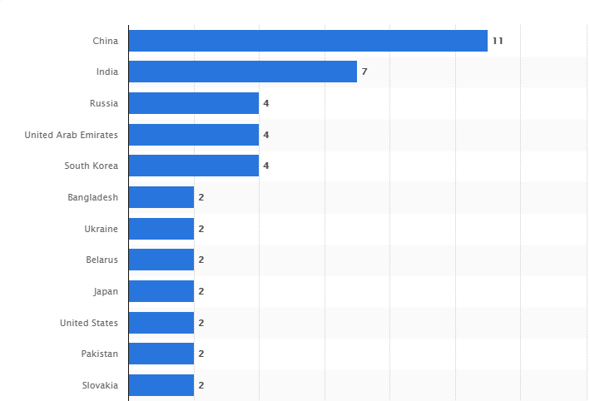
Figure-8 (Number of under construction nuclear reactors worldwide as of May 2020) (world-today, n.d.)
When looking at the number of nuclear reactors under construction around the world as of May 2020, we will find that their number is small. As America has two reactors under construction now. In addition to government grants that we can use to upgrade our business.

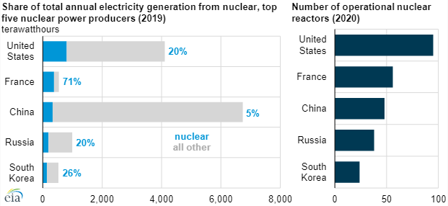
Figure-9 (annual electricity) (world-today, n.d.)

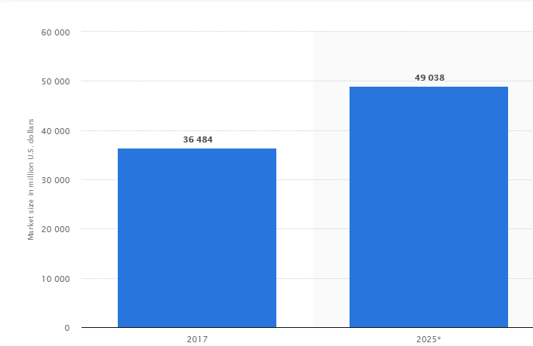
Figure-10 (market size ) (world-today, n.d.)

After we got a lot of data and divisions from many statistical sites, we knew the extent of each country’s development of nuclear engines. Accordingly, we must target the internal market first because of the large deficit in the products that we produce, then move to the external market.

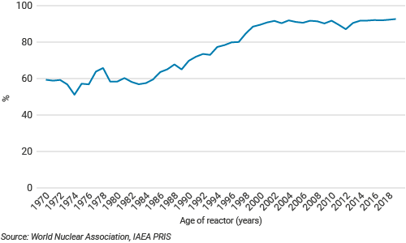
Figure-11 ( US plants capacity ) (world-today، بلا تاريخ)

Marketing plan
Marketing is one of the essential fundamentals of any project, as the success of any project depends on marketing and the percentage of sales. Therefore, there are many marketing needs.
Several steps are involved in achieving success, especially in the sales and design of nuclear engines. We must follow the rules of selling products and buying raw materials at the lowest prices in the beginning, to reduce the essential cost, as the products must be sold at less than the market price.
Presence in charitable exhibitions represented by companies, philanthropic exhibitions, and purposeful activities will create a presence among large companies for our company name.
Based on the next step and what we will do in establishing a factory, an office, and a website, we must create accounts on social media. Using social media marketing to increase the opportunity for expansion, we must use ads on YouTube, magazines, Facebook, Instagram, Twitter, and TVs.

There are many steps to a marketing strategy
1- Social media
Social media plays a massive role in the success of any project. You can use Facebook, Instagram, and Twitter and post some paid ads to reach the most significant number of companies.
2- Video clips
Create some videos and publish them on YouTube, but their budget will be high so we will use these videos in the next stage.
3- LinkedIn
No business can be considered authentic without LinkedIn. So relying on LinkedIn will create an actual entity for the company
4- Conferences and charity parties
Participation in charitable celebrations and conferences will make us a presence among other companies and create a name for us among them.

5- Old fashioned marketing
You must use old marketing by sending emails to companies or sending some representatives to specific companies to contract with them. We will target some of the companies that will receive our goods and designs.

Projection

 | First year | Second year | Third year
Sales | 500,000 | 650,000 | 845,000
Fuel and energy purchases | 30,000 | 39,000 | 50,700
Other external expenses | 12,000 | -8,739 | -11,361
Taxes other than income taxes | 2,000 | -3,541 | -4,603
Other operating income and expenses | 4,000 | 6,487 | 8,433
Operating profit before depreciation and amortisation | 452,000 | 616,793 | 801,831
Net changes in fair value on Energy and Commodity derivatives, excluding trading activities | 1500 | 1,650 | 1,815
Net depreciation and amortisation | 1,000 | 1,100 | 1,210
Net increases in provisions for renewal of property, plant and equipment operated under concessions | 2000 | 2,200 | 2,420
(Impairment)/reversals | 0 | 0 | 0
Other income and expenses | -7000 | 1,363 | 1,499
Operating profit | 440,500 | 613,206 | 797,885

Figure-12 (income statement)

 | first year | Second year | third year
ASSETS | first year | Second year
Goodwill | 0 | 20,000 | 30000
Other intangible assets | 0 | 0 | 0
Property, plant and equipment | 0 | 2,500,000 | 3,000,000
Investments in associates and joint ventures | 0 | 150,000 | 250000
Other non-current Assets | 150,000 | 600,000 | 850000
Inventories | 200,000 | 700,000 | 950000
Trade receivables | 70,000 | 110,000 | 230000
TOTAL ASSETS | 420,000 | 4,080,000 | 5,310,000
Figure-13 ( Total Assets)

I have analyzed many companies operating in the same activity to determine the extent to which they achieve profits and the time to avoid loss.
We have taken the optimal analysis and expressive analysis of UniStar Nuclear Energy as one of the best global companies in the same field.

Recommendation
- Adherence to environmental laws to reduce environmental pollution is one of the essential elements of the threat, so it is necessary to abide by environmental rules in New Mexico.
- Following the tax laws will let us know what we must follow and understand our actual gains, and if we can, we can manipulate some rules to reduce tax payments.
- Marketing is one of the essential means of success, so you must create various marketing campaigns
- .Buying cheap raw materials from some obscure suppliers at the beginning of our path, will reduce our costs, and we can increase profits

References
Abbey, D., 2019. Report of the Legislative Finance Committeeto the Fifty-Fourth Legislature, s.l.: s.n.
acf, n.d. acf. [Online]
Available at: https://www.acf.hhs.gov/ohs/funding
biz, n.d. biz. [Online]
Available at: https://gonm.biz/business-development/start/small-business-incubators-accelerators
buck.house, n.d. buck.house. [Online]
Available at: https://buck.house.gov/services/resources/grant-applicants
elibrary, n.d. elibrary. [Online]
Available at: https://www.elibrary.imf.org/view/IMF022/12418-9781616352875/12418-9781616352875/12418-9781616352875_A005.xml?language=en&redirect=true
energy, n.d. energy. [Online]
Available at: https://www.energy.gov/articles/president-trump-signs-bill-boost-advanced-nuclear-america
globenewswire, n.d. globenewswire. [Online]
Available at: https://www.globenewswire.com/news-release/2019/11/18/1948421/0/en/The-nuclear-power-plant-and-equipment-market-accounted-for-revenue-of-36-484-million-in-2017-and-is-anticipated-to-generate-49-038-million-in-2025-growing-at-a-CAGR-of-3-7-from-201.html
Levitan, D., 2020. First U.S. Small Nuclear Reactor Design Is Approved. [Online]
[Accessed 9 September 2020].
macrotrends, n.d. macrotrends. [Online]
Available at: https://www.macrotrends.net/countries/USA/united-states/inflation-rate-cpi
macrotrends, n.d. macrotrends. [Online]
Available at: https://www.macrotrends.net/countries/MEX/mexico/inflation-rate-cpi
Moise, S. K., 2018. NEW MEXICO STATE INVESTMENT COUNCIL ANNIVERSARY REPORT 2018, s.l.: s.n.
newmexico, n.d. newmexico. [Online]
Available at: https://www.newmexico.gov/2020/04/13/2287/
sba, n.d. sba. [Online]
Available at: https://www.sba.gov/article/2020/jun/18/sbas-economic-injury-disaster-loans-advance-program-reopened-all-eligible-small-businesses-non
sic, n.d. sic. [Online]
Available at: https://www.sic.state.nm.us/land-grant-permanent-fund.aspx
wcginc, n.d. wcginc. [Online]
Available at: https://wcginc.com/business-services/s-corp-salary/
world-nuclear, n.d. world-nuclear. [Online]
Available at: https://www.world-nuclear.org/information-library/nuclear-fuel-cycle/nuclear-wastes/radioactive-waste-management.aspx
world-nuclear, n.d. world-nuclear. [Online]
Available at: https://www.world-nuclear.org/information-library/safety-and-security/safety-of-plants/safety-of-nuclear-power-reactors.aspx
world-today, n.d. world-today. [Online]
Available at: https://www.world-nuclear.org/information-library/current-and-future-generation/nuclear-power-in-the-world-today.aspx
Yurman, D., 2019. SMR reactors: questions the “new nuclear” industry needs to answer, s.l.: s.n.

